# Affordable Housing Project

## MGMT 658 - Project Management

## Spring 2023

Mar 1, 2023

## Group 1

Chandratej Kurella

Jeffrey Teng

Manisha Boyina

Ruchika Balani

Sandeep Aleti

Sarthak Meliwal

Soha Mohammed

Swetha Srinivasan

# 

# Table of Contents

**Affordable Housing Project 1**

MGMT 658 - Project Management 1

Spring 2023 1

Group 1 1

**Table of Contents 2**

**Introduction 4**

**Project Scope 5**

Project Objective 5

Deliverables 5

Milestones (Phase 1) 5

Technical Requirements 6

Limits & Exclusions 6

Stakeholder Review 6

**Project Planning 6**

Project Organization and Resource 6

Resource Management 8

Work Breakdown Structure 9

Cost Analysis and Budgeting 12

Cost Analysis for 100 Houses 13

Labor Cost Breakdown for 100 houses 13

Project scheduling and resource allocation 14

Additional budget requirement due to change in total duration of the project due to labor constraints: 18

Cost Analysis for 100 Houses After Resource Leveling 19

**Project Executing 19**

Description of Changes 19

Approaches For Handling The Changes 21

Resources and cost impact due to the changes 22

Budget impact 23

Additional budget requirement 24

Insurance 24

Expected Results 24

Tasks required to close the project 24

Conducting 360- review and Team evaluation feedback 25

Project Outputs and outcomes 26

Learning lessons for future projects and identifying areas for improvement 26

**Conclusion 29**

**References 31**

**Appendix 35**

Work Breakdown Structure 35

Budget 36

Work Breakdown Structure after Resource and Cost Impact. 37

# 

# Introduction

While shelter and affordable housing is considered as one of the bare minimum necessities of a family, the current California housing market crisis is undermining the California Dream for families across the state; thereby threatening the state’s long-term growth and prosperity. Affordable housing is becoming increasingly rare to find for Californians. The lack of housing inventory, coupled with inflation and zoning inequalities, has required families to stretch more financially to find housing — and in some cases has even priced out most families, especially those who start with little-to-no capital of their own.

According to 2019 figures, while the United States was roughly 3.8 million homes short of what was needed to house the families, California has the largest housing deficit of any other state, requiring an estimated million more homes to meet housing demands. Also, a recent 2020 report on the California Housing Market reported that while the average purchase price of a Single-Family Home in the United States is around $ 95,000, that in the state of California is around $ 200,000, in other words, thrice the US average price. While the average asking purchase price in California has increased by 257% since 2012, the average annual income of the California homeowners is not increasing at the same pace (*California Housing Affordability Update* – Q4-2022 - Traditional Affordability Index, 2023).

As a resolution to the current crisis, the State Government of California has announced an ambitious housing cum livelihood program ‘LIFE’ (Livelihood Inclusion and Financial Empowerment) which aims to build and provide a total of 1.2 million affordable new homes to the California housing market. These homes will be available to purchase for the current non-homeowners in the state. The initiative majorly aims at:

* Building 1.2 million new affordable homes,
* Cost effective construction of housing units without compromising on quality,
* Put an end to homelessness in California,

The initiative in addition to ending homelessness is expected to create an impact in the housing market by:

* Close racial equity gaps in homelessness, housing affordability, housing stability, homeownership, and access to opportunity
* Helping nearly 50,000 low- and moderate-income Californian’s purchase homes
* Protecting approximately 145,000 affordable homes from entering the speculative market
* Creating more than 500,000 market-rate homes
* Helping 8 million Californians access and stay in affordable homes

Given the volume of the initiative, to ensure proper execution, the chosen approach is to divide the initiative into separate phases and consider each phase as a separate project.

# Project Scope

## Project Objective

Build 1,000 high - quality new affordable single-family homes in a cost effective manner with a budget of $ 389 million, ensuring their availability to 1000 low and moderate - income Californians by Nov 28th, 2028 at an affordable price.

## Deliverables

* A 1000 square-foot finished home, with 2 Bedrooms and 2 Baths.
* Exterior finish in accordance with environmentally preferable products.
* Interior finishes using environmentally preferable materials according to ASID Sustainable Design Council.
* Kitchen appliances include range, oven, microwave and dishwasher.
* A 1-car, detached, finished garage, insulated and sheet rocked.

## Milestones (Phase 1)

* Foundation
* Concrete
* Framing, Plumbing, Electrical
* Interior
* Roofing
* Painting, Landscaping
* Inspection

## Technical Requirements

* The structure will be built with a minimum of 2 X 6 inch sustainably sourced framing to allow for increased insulation and structural stability.
* Exterior wall insulation must meet an “R” factor of 21.
* Ceiling insulation must meet an “R” factor of 38.
* Floor insulation must meet an “R” factor of 25.
* All windows and doors must pass NFRC class 40 energy ratings.
* Homes must meet local building codes.
* Structures must pass seismic stability codes.
* Garage will have a motor operated door that has a 2 years warranty.

## Limits & Exclusions

* Refrigerators are not included in kitchen appliances.
* Development of driveways beyond 500 feet from the building site.
* Contractor reserves the right to contract out services.
* Contractor is responsible for subcontracted work.
* Providing electrical power, sewage, natural gas, and water services to the site,
* Maintenance contracts and inspections (e.g. septic system)

## Stakeholder Review

Board of Directors

# Project Planning

## Project Organization and Resource

A project organization will generally be terminated when the mission is accomplished. According to the Project Management Institute, project management is the art of directing and coordinating human and material resources throughout the life of a project by using modern management techniques to achieve predetermined objectives of scope, cost, time, quality, and participation satisfaction.

With the help of this project organization, we will try to reduce social service costs by providing targeted health and social services and help end the cycle of homelessness. Services for low-income families may include adult education, financial literacy programs, health and wellness programs, childcare, and after-school programs.

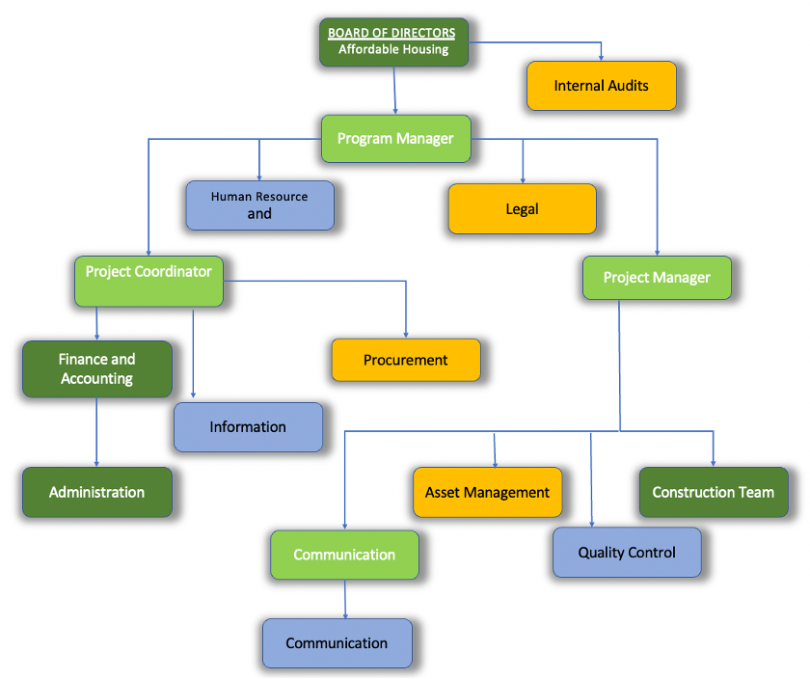

Fig1. Projectized Organization Structure

To implement the organization structure we would require:

1. A target group: which can be the stakeholders, directors, project owners who need project information to make decisions and/or contribute to project progress.
2. What information is pertinent to stakeholders?: Top management needs to know how the project is progressing, whether it is encountering critical problems, and the extent to which project goals are being realized. This information is required so that they can make strategic decisions and manage the portfolio of projects.
3. Sources of information: information relating to the milestone report, team meetings, and project status meetings would be found in the minutes and reports of various groups.
4. Dissemination modes: many companies are using the Web to create a “virtual project office” to store project information. Project management software feeds information directly to the website so that different people have immediate access to relevant project information.
5. Responsibility and timing: a common practice is to have secretaries of meetings forward the minutes or specific information to the appropriate stakeholders. Timing and frequency of distribution appropriate to the information need to be established.

## Resource Management

Resources for this project must be used efficiently to ensure success. Equipment for surveying will be borrowed from California State University East Bay and appropriate procedures will be followed for scheduling and check out. Computer drafting will be completed on school computers and availability of necessary software must be confirmed. A budget for completion of the project will be developed and reviewed weekly to ensure the time allotted on a task is properly executed.

The 1.2 million homes will be built over several phases, with each phase the company intends to construct 1,000 homes. There will be ten concurrent construction teams, each having roughly 150 workers, building 100 units apiece. Each team will have a set of veteran laborers who will look over the resources like concrete, wood, steel, stone and bricks and the respective equipment required to complete the construction of a house. Specifically, the construction team will have a general foreman, field engineer, specific skilled foremen (for carpentry, painting, electrical, etc.), architects, structural engineers, and project managers to name a few (*PMProblems*, 2022; Harris, 2023).

## Work Breakdown Structure

A combination of market estimates and prior experience informed the project manager about how long each work package will require. By extrapolation, each construction team was expanded to include the following laborers. Not included in this list are contractors for activities under earthwork and landscaping. Since the organization currently does not have the resources for soil testing (1.1.1), leveling (1.1.2), and landscaping (1.9), these activities have been outsourced.

1. 10 crews for foundation (*Residential Construction Schedule*, n.d.)
2. 1 crew for carpentry (*Residential Construction Schedule*, n.d.)
3. 1 crew of 2 electricians (*How Long Does It Take to Wire a House for Electricity? | Finddiffer.Com*, n.d.)
4. 1 crew of 2 plumbers (lanchushki131, 2021)
5. 2 crews of 8 drywall laborers each (16 total) (*How Long Should It Take to Install and Finish Drywall?*, n.d.)
6. 5 crews of 2 people each for flooring (10 people total) (*What To Expect From A Hardwood Flooring Installation*, 2021)
7. 1 crew of 2 painters (wildwestpaint, 2020)
8. 1 crew of 7 roof-laying laborers (McCarter, 2021; *Right Size Crew?*, n.d.) and
9. 1 crew of 2 inspectors

The work breakdown structure (WBS)[1] has been created with one construction team in mind. The other 9 teams will follow the same timeline and therefore the same WBS since they work synchronously. At the end of the WBS, all ten teams would have completed the 100 units they were responsible for, contributing to the total 1,000 units of housing.

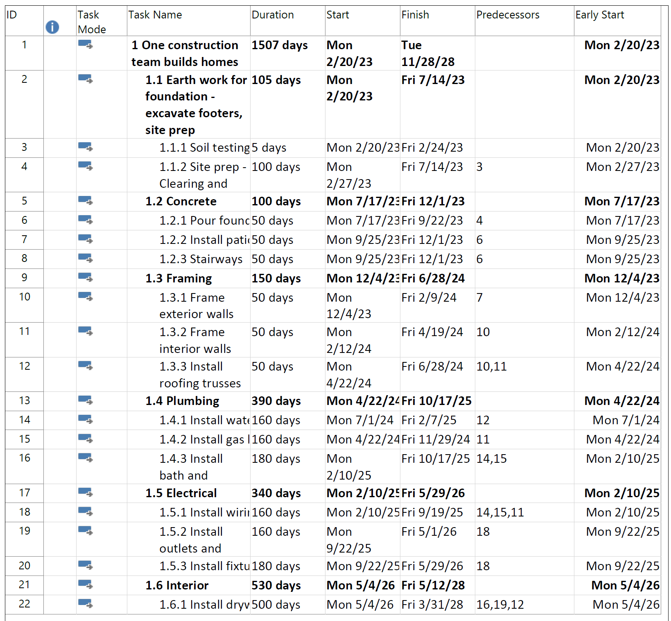

Fig. 2.1 Work Breakdown Structure for one construction crew - Part 1

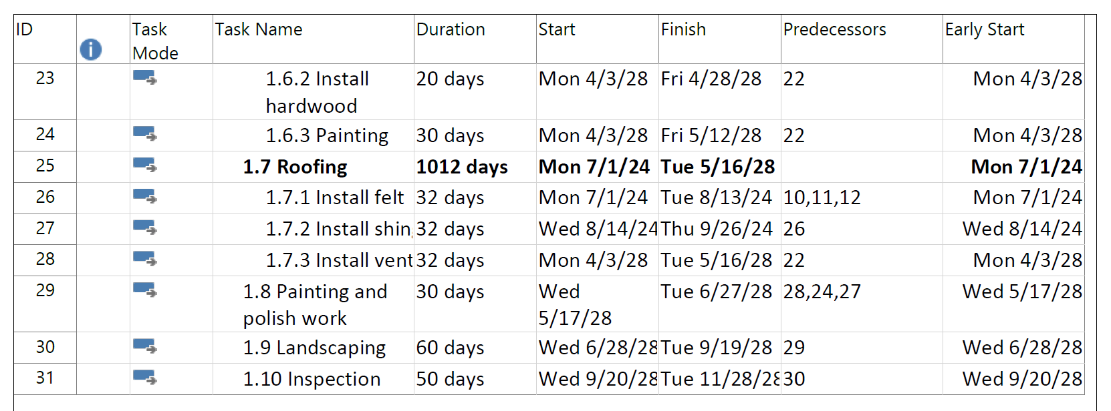

Fig. 2.2 Work Breakdown Structure for one construction crew - continued

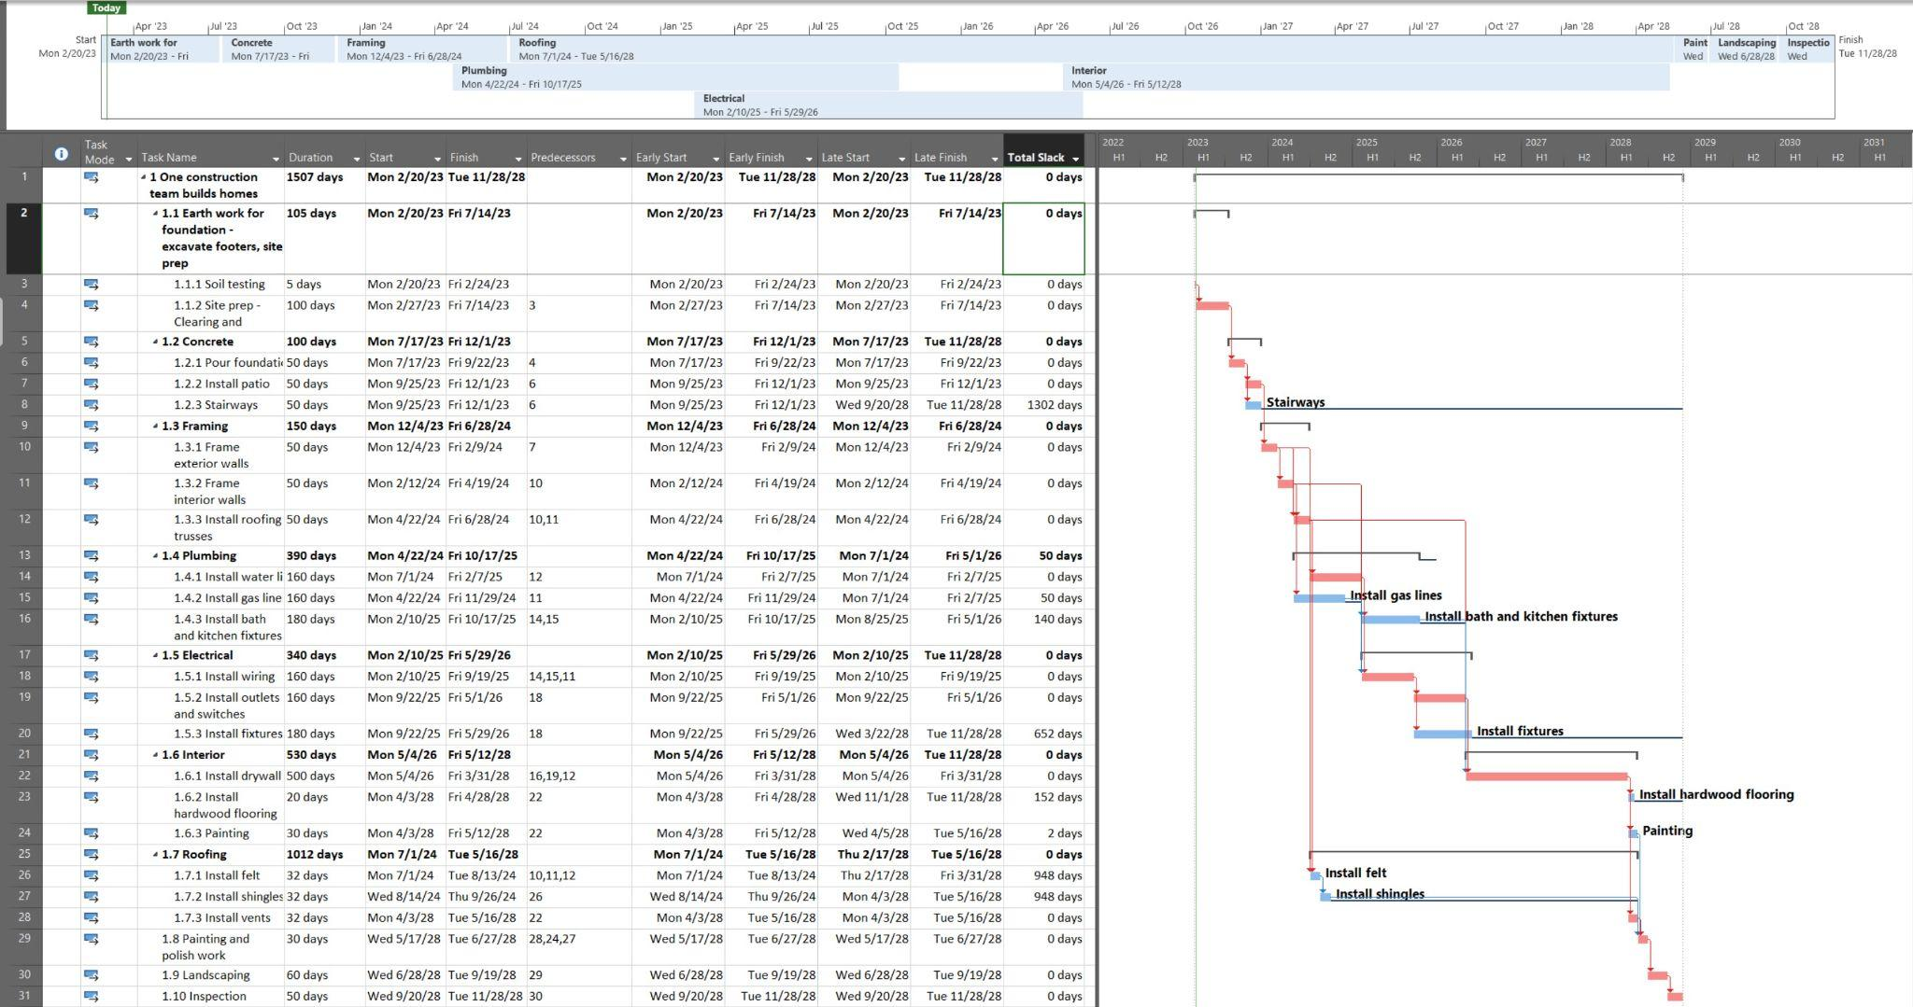

Fig. 2.3 Gantt chart for building 100 homes

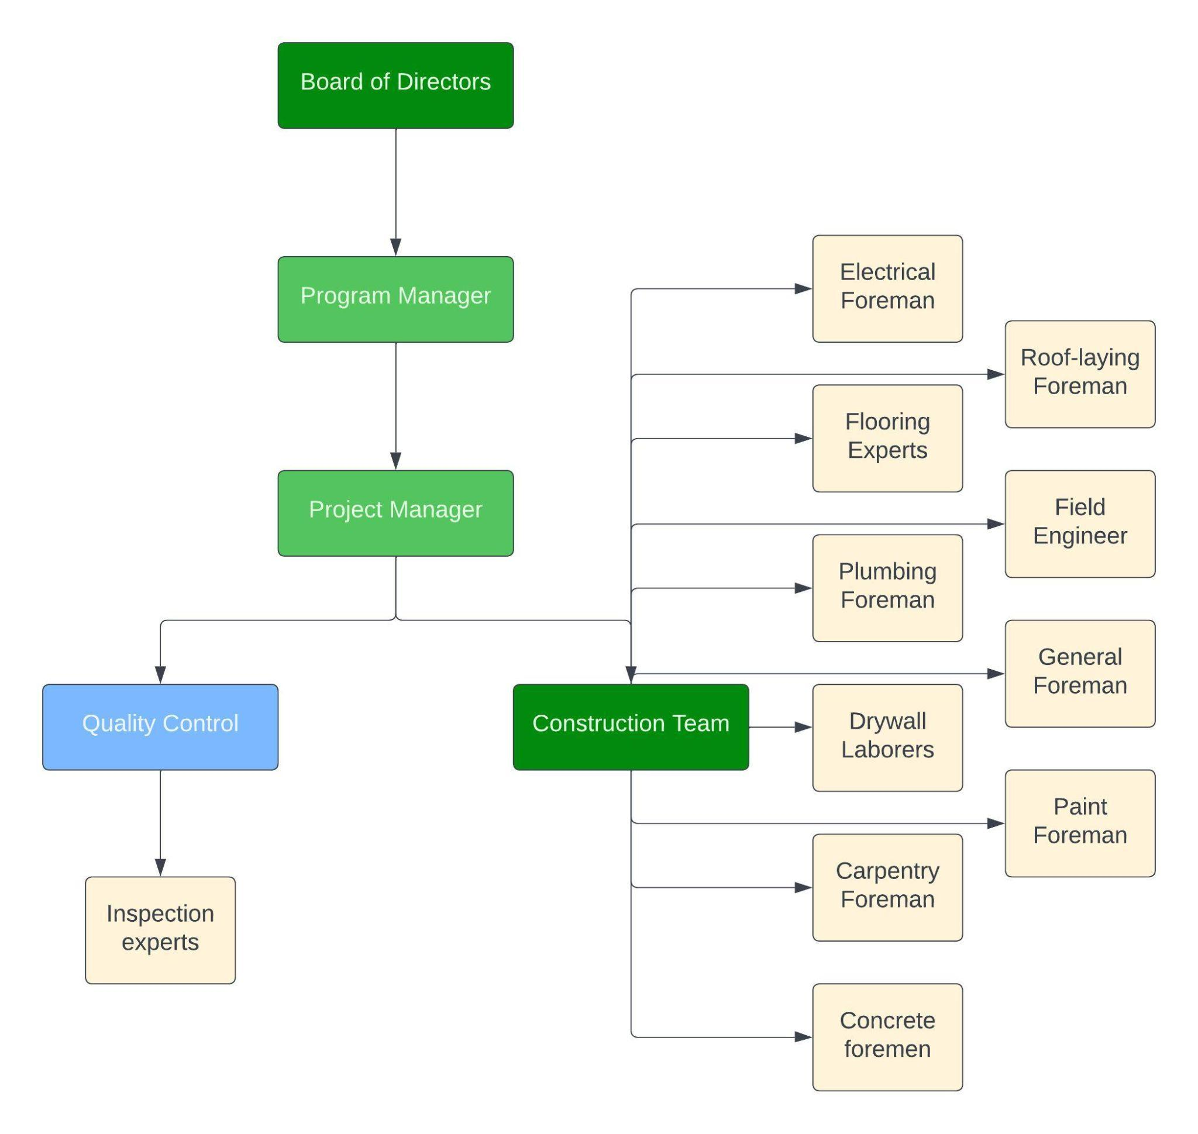

Fig. 3 Organization Breakdown Structure reflecting the teams assigned to work packages

## Cost Analysis and Budgeting

The budget consists of three different costs, direct cost, indirect cost, and the potential cost of risk. Direct cost consists of labor and materials cost. Labor costs are calculated by the total work hours x average California hourly rate of each profession x number of personnel. The material cost in California is average of $50 per square foot. For indirect cost, it consists of insurance, permit and land cost. The insurance is $85 per person per month, the permit is $1200 per house, and the land is $200 per square foot. As for the potential cost of risk, the risk is 20% of the total cost to cover the avoidable and unavoidable risks of the project. Total cost for 100 houses is $38.9 million and to complete 1000 houses, it will need $389 million.

| **Total Cost for 1000 Houses** | $ 389,030,160.00 |
| --- | --- |
| **Total Cost for 100 Houses** | $ 38,903,016.00 |

### Cost Analysis for 100 Houses

| **Direct Cost** | **Cost** |
| --- | --- |
| Labor | $6,506,640.00 |
| Material | $5,000,000.00 |
| **Total Cost** | **$11,506,640.00** |

| **Indirect Cost** | **Cost** |
| --- | --- |
| Insurance | $792,540.00 |
| Permit | $120,000.00 |
| Land | $20,000,000.00 |
| **Total Cost** | **$20,912,540.00** |

| **Potential Cost of Risk** | **Cost** |
| --- | --- |
| Risk | $6,483,836.00 |

### Labor Cost Breakdown for 100 houses

| **Labor Cost Breakdown** | **Total Work Hours** | **Average Labor Rate (per hour)** | **Crews** | **Total Cost (USD)** |
| --- | --- | --- | --- | --- |
| Foundation Worker | 1,640 | $20 | 10 | $3,280,000.00 |
| Carpenter | 1,200 | $35 | 1 | $210,000.00 |
| Electrician | 2,720 | $46 | 1 | $250,240.00 |
| Plumber | 3120 | $70 | 1 | $436,800.00 |
| Drywall Installer | 4000 | $30 | 2 | $1,920,000.00 |
| Floor Installer | 160 | $65 | 5 | $104,000.00 |
| Painter | 480 | $35 | 1 | $33,600.00 |
| Roofer | 768 | $40 | 1 | $215,040.00 |
| Inspector | 400 | $40 | 1 | $32,000.00 |
| Landscaper | 480 | $26 | 1 | $24,960.00 |

## Project scheduling and resource allocation

After resources have been allocated, it is crucial to ensure the following:

* Are the assigned labor and equipment adequate and available to manage the project?
* Will external contractors be required?
* Are there any unforeseen resource dependencies? Has a new critical path emerged?
* To what extent can resources be used flexibly?
* Is the original deadline realistic?

The GANTT chart below illustrates activities that start concurrently or have overlapping timelines. One such instance is the installation of patios and stairways. It's essential to ensure that there's a sufficient workforce available to handle such activities to avoid any delays or bottlenecks in the construction of the 100 houses.

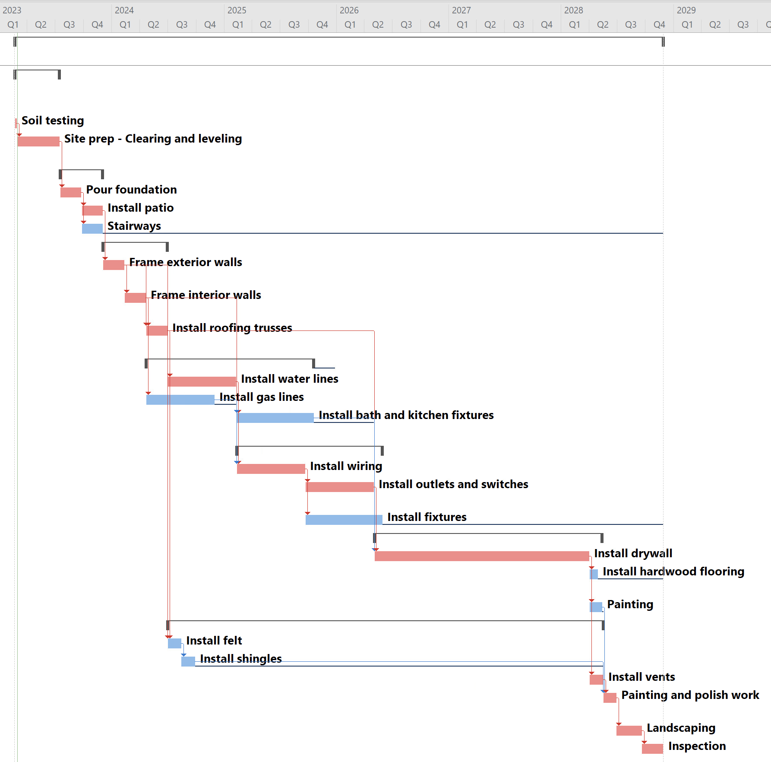

Fig. 4 GANTT chart illustration of activities that start concurrently or have overlapping timelines.

To ensure that no crew is assigned to more than one task simultaneously, we can perform resource leveling, which involves balancing the workload of the crew throughout the project. This approach helps prevent overallocation and ensure that the crew's resources are used effectively and efficiently.

The following Work Breakdown Structure (WBS) displays overallocated resources for activities highlighted in red. This indicates that the resources assigned to these specific tasks or activities exceed their available capacity or availability.

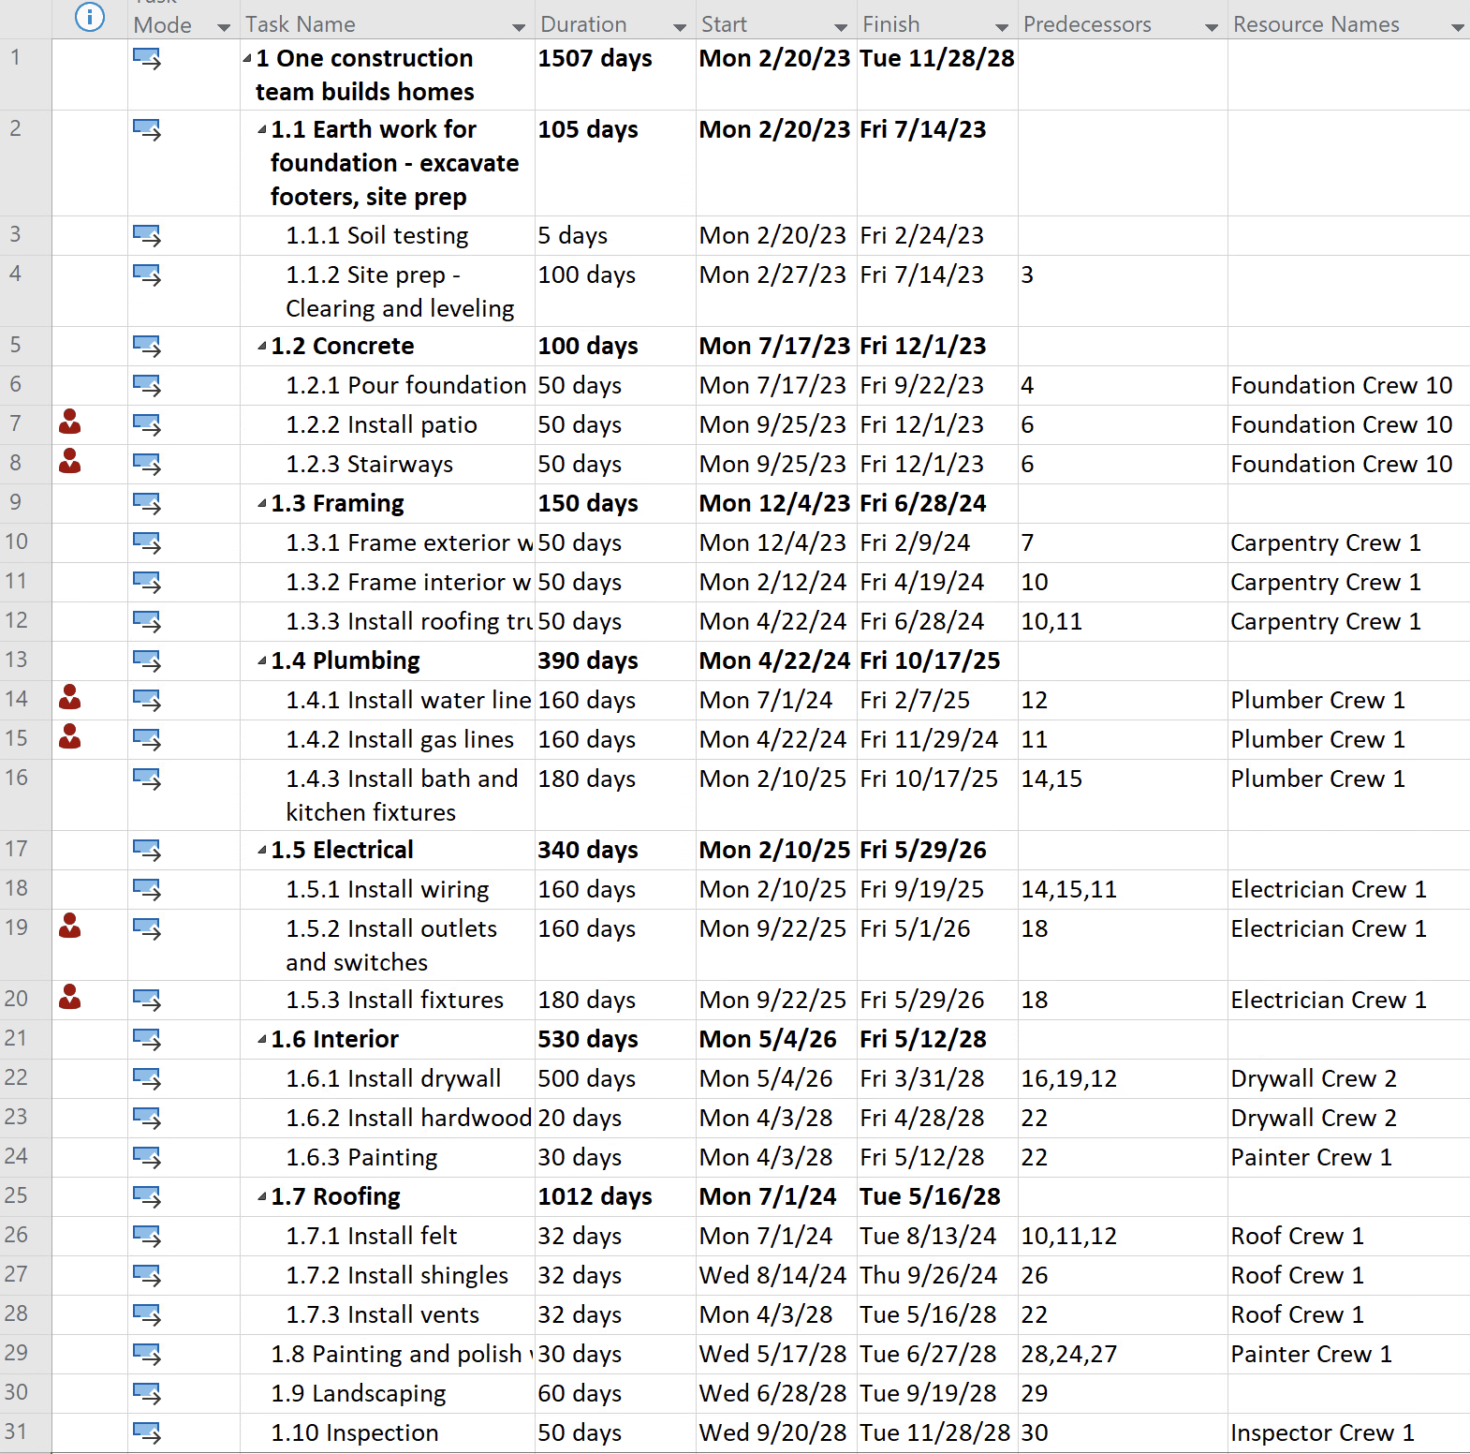

Fig. 5 WBS depicting resource overallocation for a single construction team

After performing resource leveling on the Work Breakdown Structure (WBS), we can observe in the following WBS that the resources have been adjusted to fit their availability.

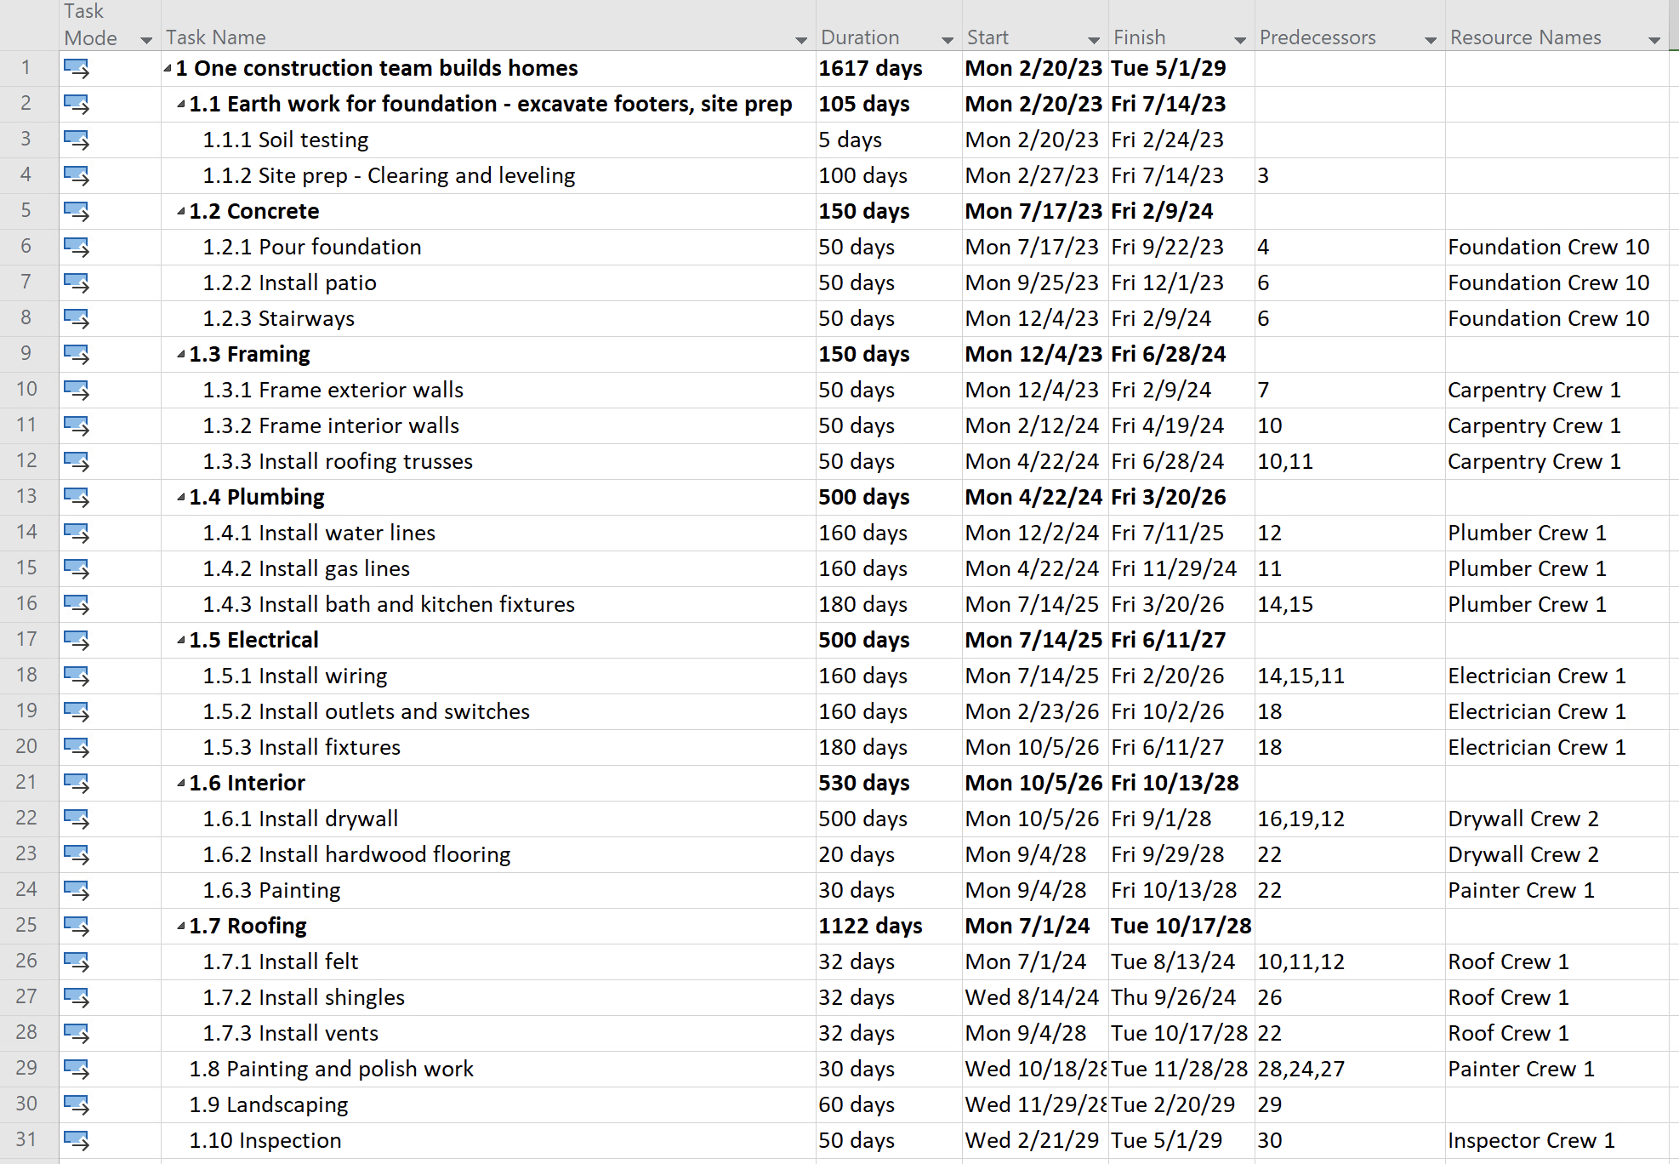

Fig. 6 Revised WBS for a single construction team after resource leveling.

To level the resources, it was necessary to extend the project's duration from 1507 days to 1617 days. Although this has increased the project's timeline, the updated Work Breakdown Structure (WBS) appears to be more realistic and feasible, taking into account the availability and capacity of resources. Also, we were able to optimize the allocation of resources by identifying periods of high demand and adjusting the allocation of resources to ensure that they are utilized effectively. This approach helps to avoid overallocation and ensures that resources are available when and where they are required, which can enhance the project's efficiency and performance.

The GANTT chart below shows a well-balanced allocation of resources throughout the project. This indicates that the necessary resources have been appropriately distributed to each activity to achieve the project's goals efficiently.

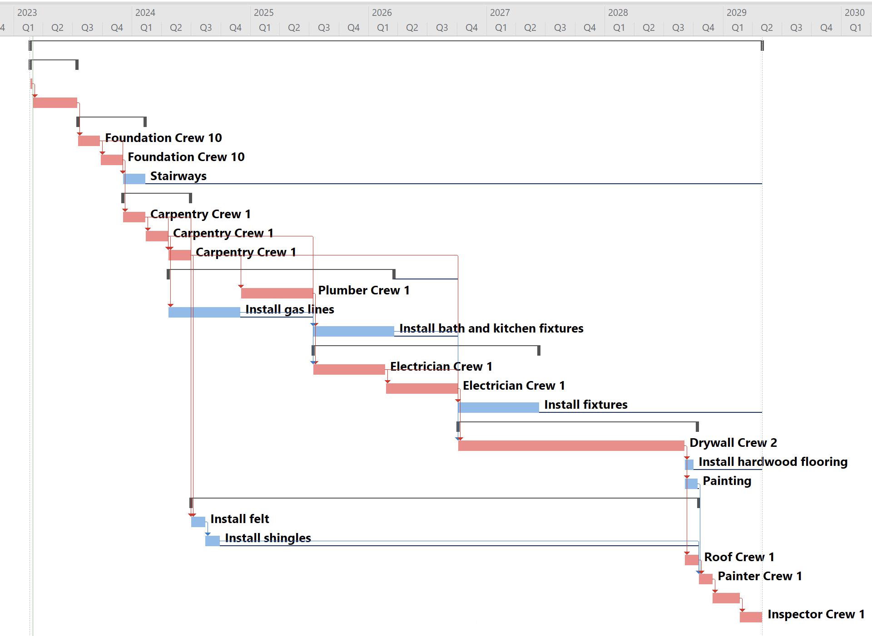

Fig. 7 Revised Gantt Chart for a single construction team after leveling its resources.

### Additional budget requirement due to change in total duration of the project due to labor constraints:

| **Total Cost for 1000 Houses** | $ 13,661,870 |
| --- | --- |
| **Total Cost for 100 Houses** | $ 1,366,187 |

### Cost Analysis for 100 Houses After Resource Leveling

| **Direct Cost** | **Cost** |
| --- | --- |
| Labor | $1,232,000.00 |

| **Indirect Cost** | **Cost** |
| --- | --- |
| Insurance | $134,187.00 |

# 

# Project Executing

## Description of Changes

Most of the changes that we encounter during the ongoing stage of the project are not anticipated in any way. Although technology has been important in handling these changes, some businesses, including the construction industry, continue to use antiquated methods. The construction sector frequently experiences several changes due to the sheer number of components that go into a single project. contractors, subcontractors, and the workers on their crews fear some changes in construction because they might affect such a large portion of the project that they throw off their planned schedule and even cause delays. Some tasks would even need starting over.

Some of the changes that we may encounter during the project's ongoing phase are listed below:

1. ***Rising Cost of Materials***: Construction materials are becoming more expensive due to several issues like tariffs, trade conflicts, inflation, or rising global demand. According to ABC (Associated Builders and Contractors, Inc.), the cost of primary construction materials rose by 5.3% between 2017 and 2018.
2. ***Labor Shortages***: The most pressing issue confronting the construction industry right now is the ongoing labor shortage. The construction industry is suffering from a labor shortage, which is causing project delays, cost overruns, and safety concerns. This problem is worsened by the fact that demand for construction work is increasing while the available workforce is not.
3. ***Weather/ Climatic Conditions***: One thing we can't control is the weather (though it would be great if we could!). Understanding that extreme weather cannot be controlled allows you to plan ahead of time, which can make a difference. Allow for a slower pace in the timeline if the weather is hot and humid, or cold and snowy, and follow safe crew practices. Another weather-related factor that you can influence is how your business will be affected in the event of a natural disaster. How well would you be able to carry on operations in the event of a tornado, hurricane, flood, fire, or earthquake?
4. ***Safety Concerns***: Falling from great heights, electrical hazards, struck-by incidents, caught-in/between incidents, and respiratory hazards are among the top safety concerns in the construction industry. These hazards can be exacerbated by insufficient safety training, a lack of protective equipment, and poor communication on the jobsite.

During the execution phase, we faced the following changes that had several consequences on the timeline and the project cost:

Labor Shortage was the first issue faced during the project execution stage since the total amount of estimated labor during the planning stage was expected to be good enough for smooth execution of the project. However, some workers were uncommitted, inexperienced and also the contractor was not quite aware that such conditions would arise in the execution stage. Due to this reason, the project ran one week behind the estimated schedule.

Weather Situation was another major issue that was delaying our Affordable Housing project as there was an unexpected flooding and we had to delay the earthwork for about 20 days and due to that The delay was unforbidden. We had to make sure that the land being used was ready for the foundation. Such conditions are completely inevitable and all we can do is be ready with some measures and metrics so as to reduce the damage and continue the process as soon as possible to avoid any further increase in the budget. Another key point is that without proper handling of the earthwork the state can withdraw the construction permit that we have.

## Approaches For Handling The Changes

Changes in a construction project are unavoidable, no matter how well you plan. However, it is critical to understand that not all changes should have an impact on the schedule, budget, or scope. Some changes are minor, while others are massive in scope, and some are unavoidable. You should be prepared for any change that may occur. Having the right tools to help you manage change is critical to staying on track. So, if we are ready and know how to handle the changes, this shouldn't be the case. The industry may address the changes more effectively so that the outcomes will still be as anticipated with good management, planning, and access to the necessary construction management software. Keeping in mind the described changes above that might occur during a project, we must have some approaches that would be able to handle the respective changes.

Labor Shortage is one of the major issues that the construction companies are being concerned about and there are few measures that we can consider to overcome this issue.

Providing training to the existing employees: if we fall short of labor and manpower, we can try training the existing labor regarding the new equipment and technological equipment emerging in the construction field and upskill them.

Expanding the recruitment efforts: Posting online ads, reaching out to hire a recruitment agency can reduce the workload of the construction company in the process of hiring labor. Also, Hiring the next generation, Leveraging technology and automation and Improving collaboration might work in handling the labor shortage.

Weather/Climatic conditions can create a huge impact on the project and we might consider some of the measures like Planning rain-sensitive activities such as earthworks to take place outside of the rainy season, Closing down buildings before the rainy season or cold weather arrives, Scheduling activities such as roofing and heavy lifting to take place outside of the windy season, Understanding the expected weather conditions and build in extra time to compensate for delays caused by inclement weather. To avoid the summer heat, begin working earlier in the day to take advantage of cooler temperatures and then finish earlier in the hot afternoons. Strong winds frequently occur in the afternoons, or windy days calm down in the late afternoon, so it may be possible to schedule lifting operations to times of day when there is less chance of winds interfering with operations - even if this means lifting occurs after normal working hours.

As discussed above the couple of factors that had an impact on our project which are Labor Shortage and Unexpected Flooding, the approaches to handle those issues are mentioned below:

Labor Shortage issue can be best addressed by training the current labor, expanding recruitment and also a quick fix for expansion of budget to get additional labor. Any one of these approaches might work to address the issue. Training the current labor can be considered when it is not easy to recruit new labor immediately. Expanding recruitment requires some time and this approach works well if we have some time buffer.

In case of any unexpected natural calamities, the management team has to be ready with certain measures to fix it as soon as possible. As in our case, the unexpected flooding has damaged some part of the construction land and we need to cover the land under construction and use a spontaneous drainage system to drain out the excess water simultaneously. These techniques would help us reduce the project extension duration.

## 

## Resources and cost impact due to the changes

It’s no secret that the construction industry is directly affected by weather events. In fact, to a certain extent, decisions related to project plans, material choices, building strategies, and labor and construction timelines are all shaped by weather and climate. While the construction industry has always been affected by weather, severe weather events have become more frequent and intense. This has led to significant economic losses and created a challenging environment.

In our project, the building site was inaccessible on some days due to Torrential Rains, the project was delayed for an additional 20 days, which affected the foundation's earth work. The activity earthwork and site prep (1.1) was originally scheduled to be completed in 105 days, from 2/20/23 to 7/14/23, but due to accessibility issues, it required an additional 5 days for the soil test, then 15 days for the site prep. The earthwork is therefore completed on 8/11/23. This delay also had an impact on subsequent activities and events.

The Work Breakdown Structure for the Affordable housing after the changes is below:

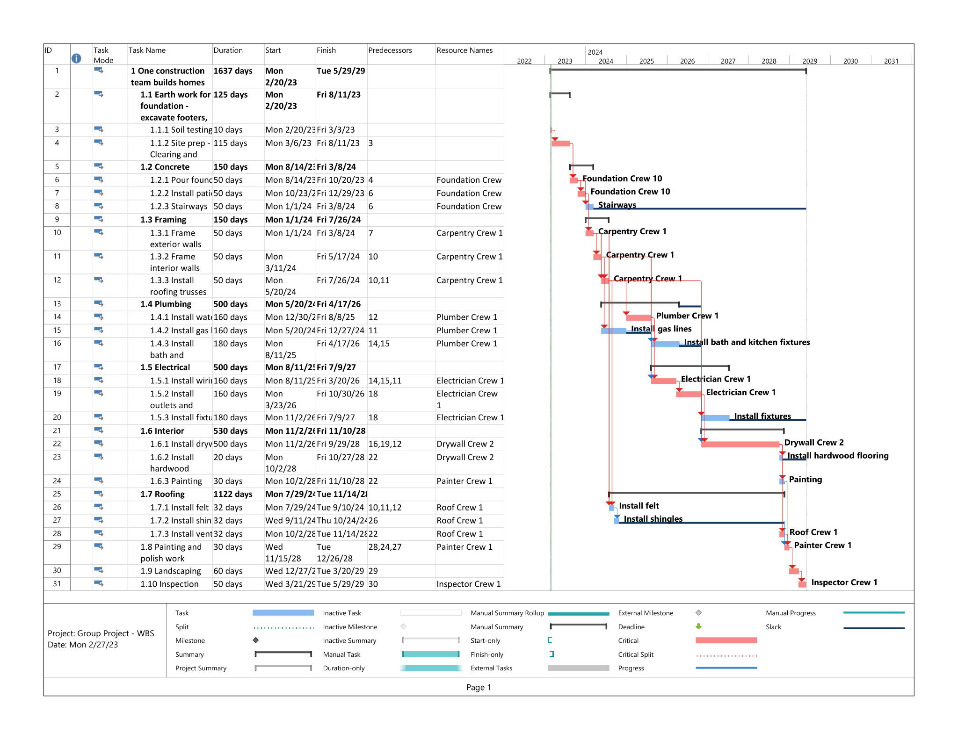

Fig. 6 Work Breakdown Structure after adjusting for weather impact

### Budget impact

Construction projects after the torrential rainfall face more difficult problems than the usual situation. One of the major problems is exceeding the budget. Torrential rain reduces visibility for workers on a site and the drivers operating heavy machinery. It can also cause less than ideal working conditions. Mud can be especially difficult to work in. It can also lead to damaged equipment or materials.

### Additional budget requirement

No. of days additionally worked = 20 days.

No. of hours worked = 20*8(average hours a day) = 160 hours.

No. of employees worked = 100.

Average labor rate = $20.

= 100 employees*160 hours* $20 = $320,000.

### Insurance

Insurance per month =$85

100 employees * 0.65 month (20 days) * $85 = $5525

Hence total additional budget = $320,000 (Labor) + $5525 (Insurance) = $325,525 (For 100 houses).

## Expected Results

In this section we are going to focus on the expected outcomes and outputs of the project based on the above planning and execution phases discussed above and in the light of the unfortunate changes that happened. Project was closed Normally, In sense project is completed. One thousand houses were built, Time for handing off the deliverables. Closure is done simply because the deliverable is completed and ready to be delivered as an output.

### Tasks required to close the project

To close any project there is usually a closure checklist in place. This list usually includes a wrap-up on the team, vendors / contractors, customer/users, and equipment and facilities.

Responsibilities for these tasks were assigned among the team members. Closure preparations will take place by Feb 1st 2029. The closure will officially take place upon project delivery and will end on May 29th, 2029. Project will be delivered as phase one on the program and phase two to start after one quarter of evaluation and corrective actions.

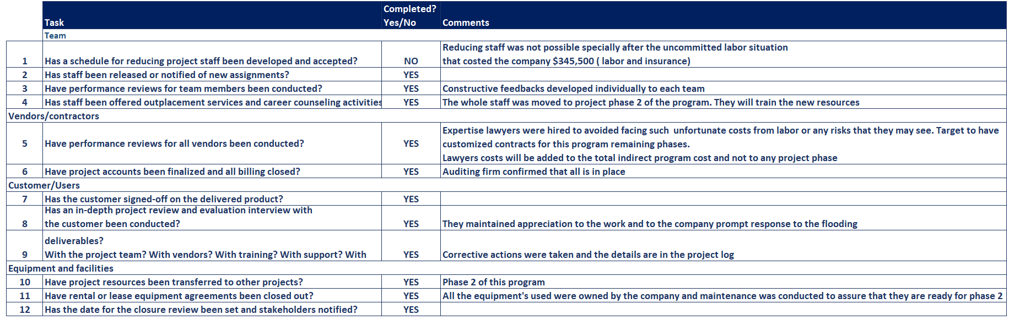

### Conducting 360- review and Team evaluation feedback

360-degree review is becoming very popular specially in project driven business types such as the cases in construction. The project management office is responsible for collecting information on a specific project manager from customers, vendors, team members, peers, and other managers.

In addition to performance reviews, data are collected for project retrospectives, where performance might be influenced. Doing that enabled us to recognize and unusual the performance gaps.

Evaluation feedbacks were distributed and data collection was conducted later followed by the analysis that led us to some conclusions as discussed in the outcomes section.

Sample from team evaluation feedback form used in the data collection phase.

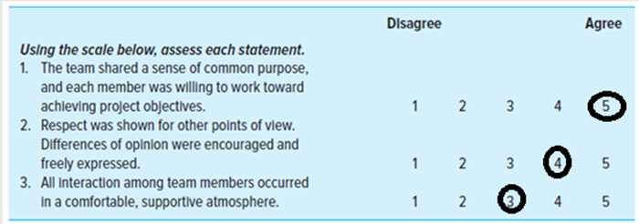

75% of the responses came out with the above results which required a deeper look. The results are discussed further at the outcomes section.

### Project Outputs and outcomes

The outputs of the project were meeting the business objective (project objective) of delivering 1000 units. Due to the unfortunate weather conditions and labor situation, along with the resource leveling issue the project ran late by 130 days and over cost by $ 1,686,742.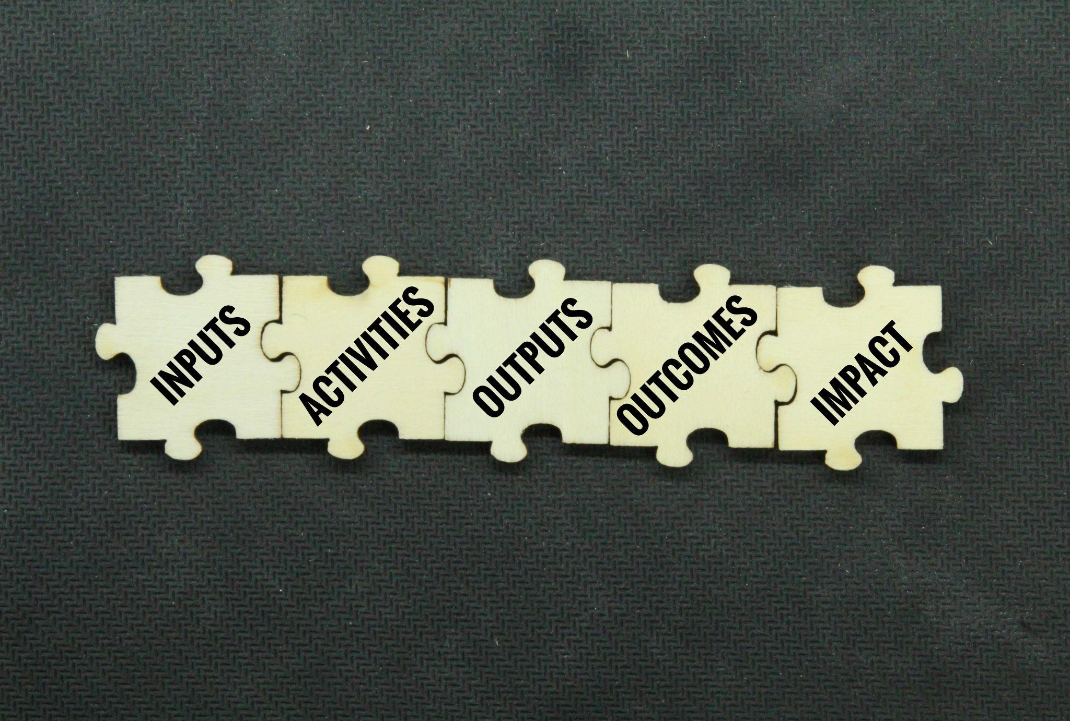

The phase of the program was considered a learning phase since this is a long term program with a huge impact on low to average income Californians. According to the published California income statistics 85% of the population are low to average income and only 15% are classified at high income. So this program will impact the lives of a segment that not only has the majority of the population but in need as well. Most of those categories now are in severe impact of inflation and recession at the same time. This project will ease their lives specially for those who had a baby living in a one bedroom apartment or expecting a baby. This would be a good investment for them and came in time. Even for newly married couples in this demographic sector they can invest in that for their future small family since the delivery will be in 5 years.

### Learning lessons for future projects and identifying areas for improvement

This program phase was more of a learning phase where we got the chance of larger exposure with limited resources. The program is a mega program and a good opportunity for the company to tap and develop in such areas.

A detailed report was raised to our company management as part of the lessons learned by the needed resources for a structured company expansion. We have noticed during the project that there are multiple resources and skill sets that were not available in the company because they were never actually needed. Since this program will be a 20-year program and based on the current assessment, we can conclude the need for the following actions:

1. Employ additional construction engineers specialized in areas such as foundation and painting. Outsourcing and contracting is convenient for short term activities. Based on the feedback collected from the teams internally even though the contractor is responsible for the work the communication channel was not smooth and sometimes the contractor stopped responding. In the beginning when those comments were raised, it sounded like the best corrective action was to add a clause in the contract forcing the contractor to reply to each single correspondence or else sanction the amount to be paid. Having the subject addressed through surveys and discussions with a couple of contractors, the root cause was unexpected. Though our staff are highly skilled, we lack the skill sets needed to understand the contractors and speak the same language. The contractors were suffering. addressing the issue in detail, it was found that the contractors teams spent a long time trying to bring our staff to the same page which cost them money to have additional resources doing the work. The situation became that contractors had a team for communicating outcomes and a team for doing the work. From the contractors point of view this was not what we got paid for. Having the weather issue the situation got complicated and contractors could not put any additional resources for smooth communication. For the future phases in this program, we see potential quality risks. Though an audit is conducted through each milestone, possible quality issues in the material used are still there. Since the company strategy is to focus on such governmental projects in different states. A restriction would be helpful at this point of time.
2. Reconsider the fixed equipment cost. The equipment used for this project is owned by the company. The depreciation cost on these equipment are extremely high in the long term having in mind the maintenance team available to assure that the machines are performing as needed. The cost viability of keeping using our equipment is not in our favor. The initial idea is to use contracted equipment since they can provide a variety of equipment along with the needed maintenance. Another key point here is that since this is their basic activity in the market, they acquire up to date technology to compete with their peers. Part of the maintenance team can be trained to manage the communication part with those contractors, the other part will join other functions. Actually we got requests from 30% of the maintenance department before showing interest to join other functions as part of the career development. This requires further discussions with the Human Resources department as to the details of training and placements that can be done to assure meeting the business needs and the commitments we have towards our employees and the community as well.
3. The way business is conducted needs to be re-evaluated including the current business structure and the number of resources. Due to the internal resources deficiency the company lost 110 days. Due to uncontrollable risks we lost 20 days.Though the government accepted that as part of phase one ( learning phase) in the program, we need to assure that this will not occur again. Risking this situation again will risk our future in such a market segment.. We might train the maintenance engineers to help out, still preventive and corrective actions need to be taken.
4. Allocate funds to risk can be decreased to 10% based on the final calculations received by auditors.
5. Measuring the performance in each milestone needs reevaluation to go hand in hand with the audit activities.
6. Tracking progress and the communication channel needs huge work to assure that they meet the needs they are there for. Communication took lots of the resources allocations that we had either from our internal team or outsourced partners. This needs to be restructured for smooth progress and better cost optimization.

The outcomes of this program phase helped in a better assessment of the current situation and in proactively assessing the procedures needed in the rest of the program.

# Conclusion



In this section of our report, we are going to summarize the whole situation. The company started this project with a scope building 1000 houses to low-middle income Californians to be delivered on Nov 28th, 2028. The project was phase one of the program that targeted 1.2 million houses to the low middle income Californians that represent 85% of the demographic income segmentation in California.

This project fits into the company's strategic expansion plans. The project was a quite resourceful learning experience for the program and for the other similar programs the company is planning to engage at.

Though the project faced weather and labor challenges, the project was delivered at the required quality level on May 29th, 2029. Almost 130 days behind the agreed upon schedule with an over cost of $ 1,686,742 . Out of those $ 1,686,742, $325,525 (For each 100 houses) were due to planning which was not even on our contrabble risks list. Though this might look negative there were lots of positive outcomes that overweight this negative point. Now the company is able to assess the actual capacities and resources involved and the type of involvement levels for such future projects. The experience itself was needed for our internal resources and external partners to be prepared for the company's future strategic direction. Training is useful to give insights and skills needed. Using these skills when needed is different. This project enabled us as a company to reassess different capacities including the human resources deployment. Conducting 360- review enabled us to have better exposure to the lessons learned. This will improve the company performance during the rest of the programs and for similar programs. Key point that was not expected by the whole team is that resource leveling causes 110 days of delay and other uncontrollable risks cost the company only 20 days. Usually the situation is the other way around. The resources are mainly internally and failing to plan the resources correctly led to such an unfortunate situation. Planning is a key point for any project success. failing to plan is just a plan to fail. We need to reassess our internal capacities and capabilities looking for the root cause. The company has not faced such a problem before so if we do not have enough resources to conduct planning as needed we might consider having additional resources. If the resources are enough then we might need to consider appropriate training for such types of programs. Since this is a new company direction ( strategic direction), this point needs to be sorted out ASAP. Resource leveling was never even considered as one of the company controllable risk factors. Having 110 days from resource leveling vs 20 days from uncontrollable risks such as weather and subcontracted activities is something major that requires collaboration and understanding.

Another major action point was the contracting and the customized legal contracts needed for such projects. Though this project is in the core of the company activities, we were able to realize that with such a high scale the situation is different. This made us learn as a team better approaches that improve the work quality and reduce cost such as outsourcing. Though outsourcing for equipment was never desired by the company management. Now and after this project, it became a must due to the costs involved that might affect the profitability and new technologies that will be needed along with the human resources costs involved but not limited to salaries and training. This point requires a corrective and a preventive action as well.

Accordingly we can conclude that overall the project satisfactorily fulfilled the stakeholders requirements and company current and future growth opportunities.

# References

California Association of Realtors. (n.d.). (rep.). California Housing Affordability Update – Q4-2022 - Traditional Affordability Index. Retrieved February 28, 2023, from https://www.car.org/marketdata/data/haitraditional.

Erika. (2021, May 7). Site Preparation for Construction: 9 Things (2023) You Need to Know. Gokce Capital: We Buy and Sell Land. https://gokcecapital.com/site-preparation-for-construction/

How long does it take to wire a house for electricity? | Finddiffer.com. (n.d.). Retrieved February 18, 2023, from https://finddiffer.com/how-long-does-it-take-to-wire-a-house-for-electricity/

How long should it take to install and finish drywall? (n.d.). Retrieved February 18, 2023, from https://www.biggerpockets.com/forums/67/topics/719880-how-long-should-it-take-to-install-and-finish-drywall

lanchushki131. (2021, June 1). How Long Does it Take to Install Plumbing in a New House? Reliable D&P. https://reliabledp.com/how-long-does-it-take-to-install-plumbing-in-a-new-house/

McCarter, J. (2021, December 14). How Long Does It Take to Complete a Roof Replacement? John McCarter Construction. https://johnmccarterconstruction.com/how-long-it-takes-to-complete-a-roof-replacement/

Residential Construction Schedule. (n.d.). Retrieved February 18, 2023, from https://www.homebuilderassist.com/construction-schedule.html

Right size crew? — RoofersCoffeeShop. (n.d.). Rooferscoffeeshop.Com. Retrieved February 18, 2023, from https://www.rooferscoffeeshop.com/forum/topic/right-size-crew

What To Expect From A Hardwood Flooring Installation. (2021, January 19). https://www.districtfloordepot.com/blog/what-to-expect-during-your-hardwood-floor-installation

wildwestpaint. (2020, October 1). How long does it take a painter to paint a house? Wild West Paint. https://www.wildwestpaintinginc.com/how-long-does-it-take-a-painter-to-paint-a-house/

Team, F. C. (2022, June 29). *Build a House in California Cost*. Fixr.com. https://www.fixr.com/costs/build-house-california

Cooke-Davies, T., “Project Management Closeout Management: More than Simply Saying Good Bye and Moving On,” in J. Knutson (Ed.), Project Management for

Business Processionals (Indianapolis, IN: John Wiley and Sons, 2001), pp. 200–14.

Fretty, P., “Why Do Projects Really Fail?” PM Network, March 2006, pp. 45–48.

Gobeli, D., and E. W. Larson, “Barriers Affecting Project Success,” in 1986 Proceedings Project Management Institute: Measuring Success (Upper Darby, PA: Project Management Institute, 1986), pp. 22–29.

Hoffman, R., “Ten Reasons You Should Be Using 360 Degree Feedback,” HR Magazine, April 1995, pp. 82–85.

Jedd, Marcia, “Standing Guard,” PM Network, vol. 21, no. 1 (January 2007), pp. 73–77.

Kendrick, Tom, Identifying and Managing Project Risk, 2nd ed. (New York: ANACOM, 2009).

Kerth, Norman L., Project Retrospectives: A Handbook for Team Reviews (New York: Dorset House, 2001).

Kwak, Y. H., and C. W. Ibbs, “Calculating Project Management’s Return on Investment,” Project Management Journal, vol. 31, no. 2 (March 2000), pp. 38–47.

Ladika, S., “By Focusing on Lessons Learned, Project Managers Can Avoid Repeating the Same Old Mistakes,” PM Network, Vol. 22, No. 2 (February 2008), pp. 75–77.

Latham, G. P., and K. N. Wexley, Increasing Productivity through Performance Appraisal, 2nd ed. (Reading, MA: Addison-Wesley, 1993).

Lavell, Debra, and Russ Martinelli, “Program and Project Retrospectives: An Introduction,” PM World Today, vol. 10, no. 1 (January 2008), p. 1.

Marlin, Mark, “Implementing an Effective Lessons Learned Process in a Global Project Environment,” PM World Today, vol. 10, no. 11 (November 2008), pp. 1–6.

Nelson, Ryan R., “Project Retrospectives: Evaluating Project Success, Failure, and Everything in Between,” MIS Quarterly Executive, vol. 4, no. 3 (September 2005), p. 372.

Pippett, D. D., and J. F. Peters, “Team Building and Project Management: How Are We Doing?” Project Management Journal, vol. 26, no. 4 (December 1995), pp. 29–37.

Romanoff, T. K., “The Ten Commandments of Performance Management,” Personnel, vol. 66, no. 1 (1989), pp. 24–26.

Royer, I., “Why Bad Projects Are So Hard to Kill,” Harvard Business Review, February 2003, pp. 49–56.

Senge, P., The Fifth Discipline: The Art and Practice of the Learning Organization (New York: Doubleday, 1990).

Sheperd, D. A., H. Patzelt, and M. Wolfe, “Moving Forward from Project Failure: Negative Emotions, Affective Commitment, and Learning from the Experience,” Academy of Management Journal, vol. 54, no. 6 (2011), pp. 1229–60.

PMProblems. (2022, February 9). Construction project team: Roles and responsibilities of 9 key positions. PM Problems. Retrieved February 27, 2023, from https://solvepmproblems.com/construction-project-team-roles-responsibilities/

Harris, L. (2023, February 23). What are the different construction foreman jobs? Practical Adult Insights. Retrieved February 27, 2023, from https://www.practicaladultinsights.com/what-are-the-different-construction-foreman-jobs.htm

California Income Statistics - Current Census Data for Zip Codes https://www.incomebyzipcode.com/california#:~:text=Median%20Household%20Income%3A%20%2484%2C097.,make%20over%20%24200%2C000%20a%20year.

# Appendix

## Work Breakdown Structure

[Link to spreadsheet for better readability](https://docs.google.com/spreadsheets/d/1lhea8R3WInOVsNW3nmYEek-hS_XC9gkO/edit?usp=share_link&ouid=102082427374642145818&rtpof=true&sd=true)

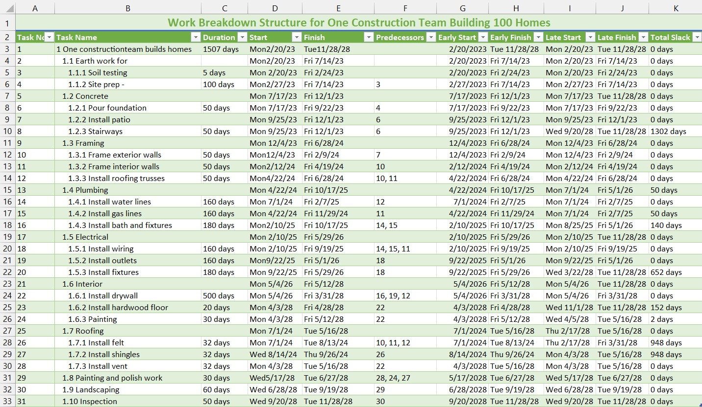

## Work Breakdown Structure after Resource Leveling

[Link to spreadsheet for better readability](https://docs.google.com/spreadsheets/d/1lhea8R3WInOVsNW3nmYEek-hS_XC9gkO/edit?usp=share_link&ouid=102082427374642145818&rtpof=true&sd=true)

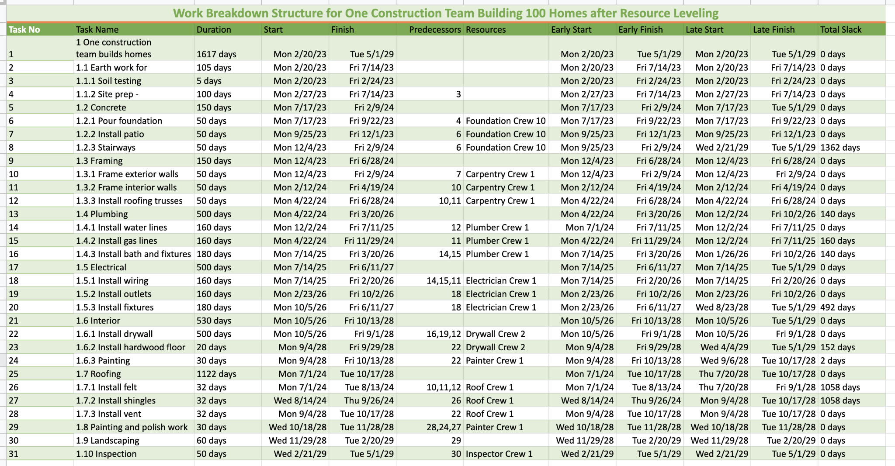

## Budget

[Link](https://docs.google.com/spreadsheets/d/1CkEyNXmMVdsgo-ScNGFS-anOE1819Zf26SBdysPb-Dc/edit?usp=sharing) to file 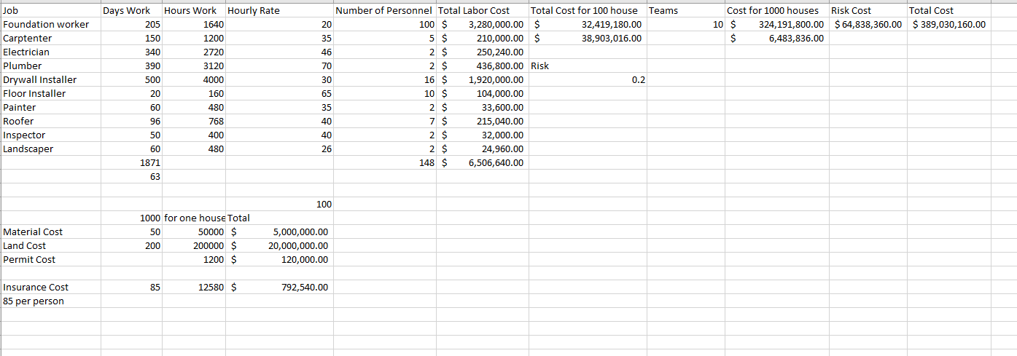

**Additional Budget after resource leveling**

[Link](https://docs.google.com/spreadsheets/d/1CkEyNXmMVdsgo-ScNGFS-anOE1819Zf26SBdysPb-Dc/edit?usp=sharing) to file

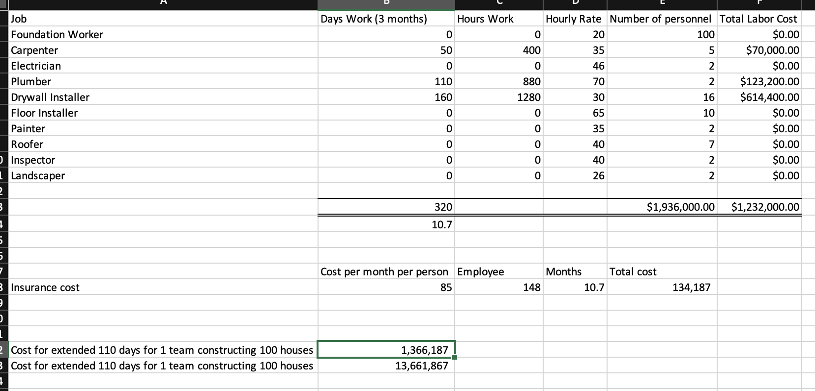

## Work Breakdown Structure after Resource and Cost Impact.



1. See appendix for detailed WBS with early times, late times, and slack.